Assignment 9 :: Deploy Ansible on One of EC2 instance and write a playbook to install httpd server and host website on two ansible hosts

Step 1 :: Create three EC2 instances and name it as below

1. Ansible_Control_Node
2. Ansible_Manage_Node_1
3. Ansible_Manage_Node_2

Step 2 :: Install Ansible in Ansible_Control_Node

Update the rhel repo to latest

# yum update -y

Install Ansible using EPEL Repository

# wget <https://dl.fedoraproject.org/pub/epel/epel-release-latest-7.noarch.rpm>

# yum install -y epel-release-latest-7.noarch.rpm

# yum update -y

# yum install python python-devel python-pip openssl ansible -y

# amazon-linux-extras install ansible2

# ansible --version

Step 3 :: Configuring Ansible in all nodes

# useradd ansadmin

# passwd ansadmin

# visudo

Add below line

ansadmin ALL=(ALL) NOPASSWD: ALL

# vi /etc/ssh/sshd_config

Uncomment the below line

“PasswordAuthentication yes”

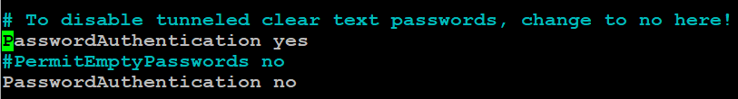

# service sshd restart

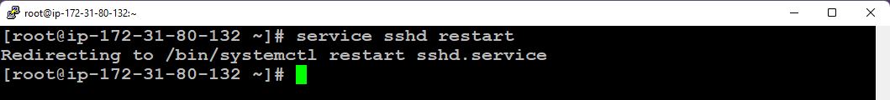

Step 4 :: Setup PasswordLess login to all the Manage Nodes from Control node via ansadmin user

# su - ansadmin

$ ssh-keygen

Copy the public key to Manage Nodes

$ ssh-copy-id -i /home/ansadmin/.ssh/id_rsa.pub [ansadmin@172.31.83.149](mailto:ansadmin@172.31.83.149)

$ ssh-copy-id -i /home/ansadmin/.ssh/id_rsa.pub [ansadmin@172.31.91.139](mailto:ansadmin@172.31.91.139)

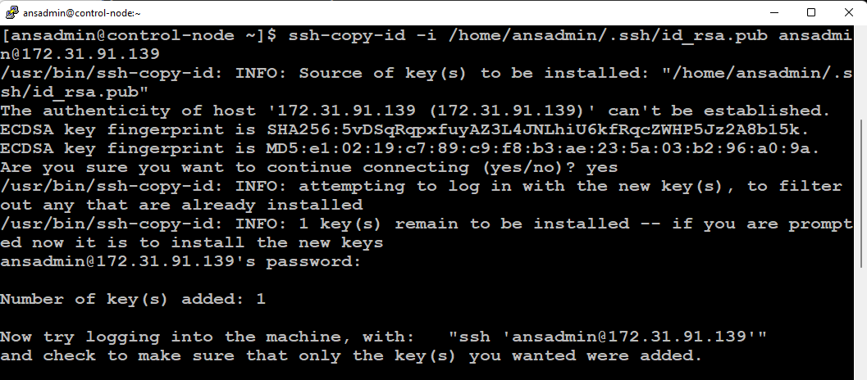

Test the PasswordLess login from control node to manage nodes

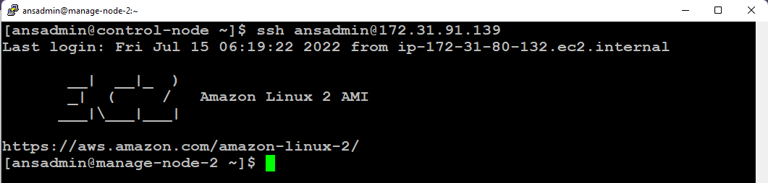

Step 5 :: Managing inventory file on Master

Add the below lines at end of file /etc/ansible/hosts

# vi /etc/ansible/hosts

172.31.91.139

172.31.83.149

[webserver]

172.31.91.139

[nginx]

172.31.83.149

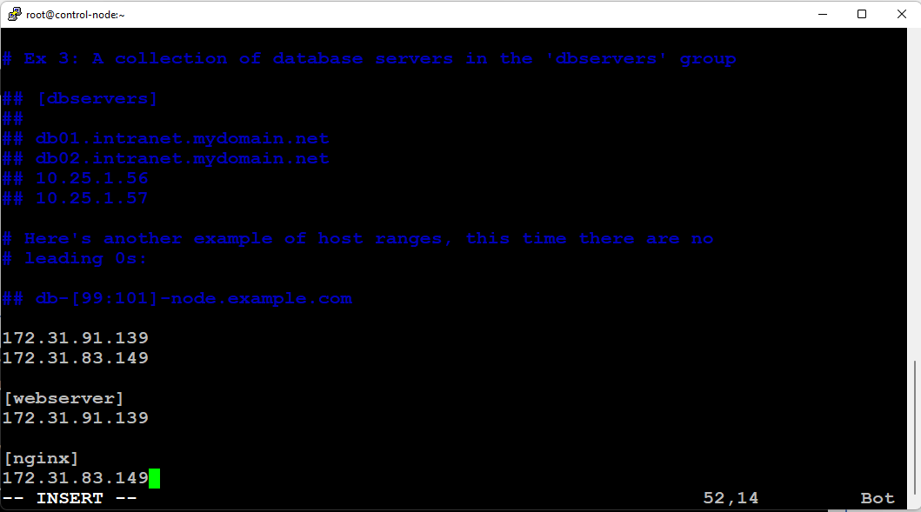

Perform Ping test from Control Node to Manage Nodes from ansadmin user

$ ansible -m ping webserver

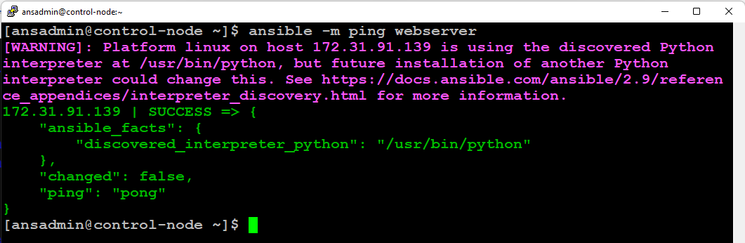

$ ansible -m ping nginx

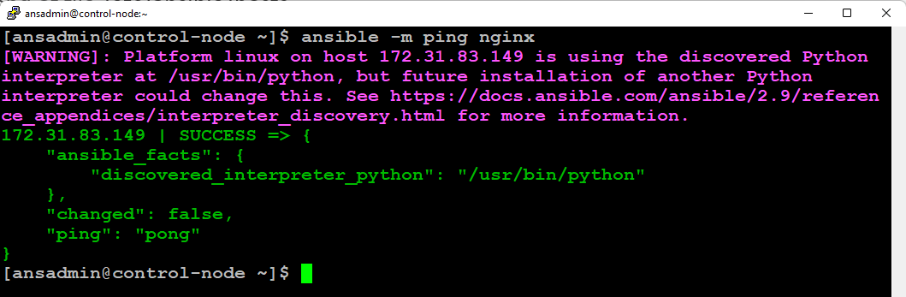

$ ansible -m ping all

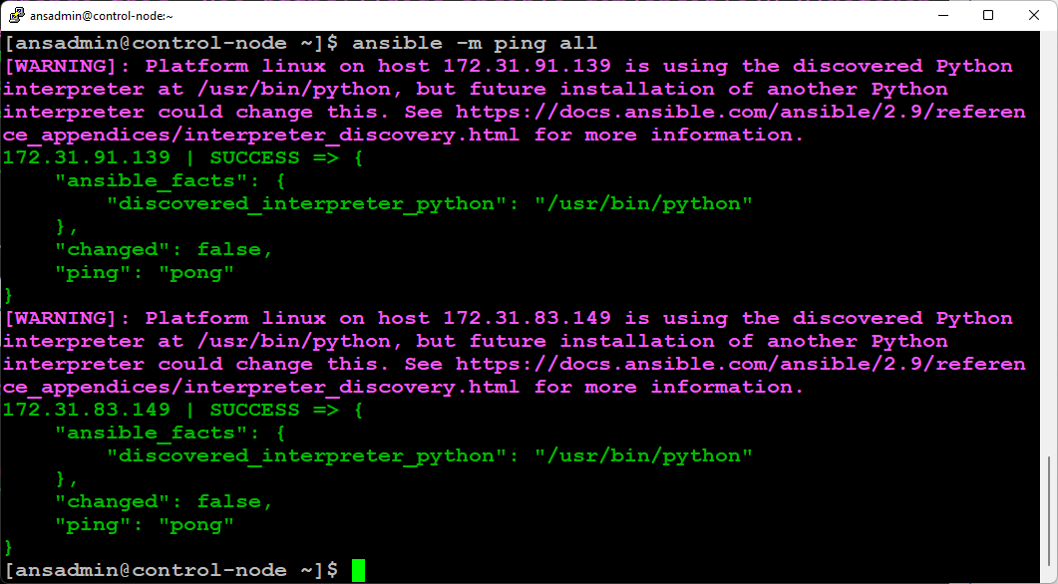

Step 6 :: Write a playbook to install httpd and copy the index.html in manage node 1 (webserver) and install nginx in manage node 2 (nginx)

[ansadmin@control-node ~]$ cat hari_playbook.yml

- name: Creating a Webserver

become: yes

remote_user: ansadmin

hosts: webserver

tasks:

- name: install httpd package

yum:

name:

- httpd

state: present

- name: start service httpd

service:

name: httpd

state: started

enabled: yes

- name: create a directory

file:

path: /devweb

state: directory

mode: 02775

setype: httpd_sys_content_t

- name: create file

file:

path: /devweb/index.html

state: touch

- name: copy the contents

copy:

content: "Welcome to Hariharan's WebServer page !!!\n"

dest: /devweb/index.html

- name: link a file

file:

src: /devweb

dest: /var/www/html/devweb

state: link

- name: Install nginx package in nginx server

become: yes

remote_user: ansadmin

hosts: nginx

tasks:

- name: Get the EPEl repo

get_url:

url: https://dl.fedoraproject.org/pub/epel/epel-release-latest-7.noarch.rpm

dest: /home/ansadmin/epel-release-latest-7.noarch.rpm

- name: install EPEL repo

yum:

name: /home/ansadmin/epel-release-latest-7.noarch.rpm

state: present

- name: install ngnix package

yum:

name:

- nginx

state: present

- name: start service nginx

service:

name: nginx

state: started

enabled: yes

[ansadmin@control-node ~]$

Run the playbook

$ ansible-playbook hari_playbook.yml

**Result:**

Webpage is configured in webserver

Ngnix is successfully installed in nginx server

